

DEPARTMENT: COMPUTER SCIENCE

Internal Assessment | I | Academic Year/Semester | 2022-23 /IV
Subject | CST204-Database Management  Systems | Branch | CSE/AI
Date of Exam | 23/03/2023 | Duration | 120 Min
Starting time | 2:00 am/4:00 pm | Max. Marks | 60

PART-A (Answer all questions, each carries 3 marks) Max Marks: 12
Q.No |  | Marks | CO | Level
1 | Define Degree of relationship. Explain with suitable diagrams. | 3 | I | L2
2 | Re-draw the ER diagram replacing the (min, max) notation with the conventional notation showing cardinality and participation.  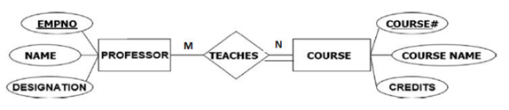 | 3 | II | L2
3 | Define Cardinality Ratio, what are the possible cardinality ratios for a  binary relationship. | 3 | II | L2
4 | What role does Relational Algebra play in Relational Database Management Systems (RDBMS)? | 3 | I | L2

PART-B (Each question carries 12 marks) Max Marks: 48
5 |  | a |  | Explain the differences between DDL and DML in DBMS, and provide a suitable example for each | 4 | II | L2
 |  | b |  | For a car-insurance company whose customers has a Unique Customer_id, Cust_name, Address, Date of birth, age. A customer owns many cars, A car can be owned by a single customer .The car is identified by unique regn no, model, year & amount insured. A person as well as a car can be involved in zero to any number of accidents. The accident is recorded by a unique report number,location ,date & damage amount. Construct the E-R diagram mentioning all the attributes and also the cardinalities of relationship. | 8 | II | L3
OR
6 |  | a |  | Briefly explain the concepts of Physical data independence & logical data independence with a typical real world example | 4 | I | L2
 |  | b |  | Design an ER diagram for the given scenario; Suppose that you are designing a schema to record information about reality shows on TV.Your database needs to record the following information: _ For each reality show, its name, genre, basic_info and participants name. Any reality show has at least two or more participants. - For each producer, the company name, company country. A show is  produced by exactly one producer. And one producer produces exactly one show. - For each television, its name, start year, head office. A television may broadcasts multiple shows. Each show is broadcasted by exactly one television. -For each user, his/her username, password, and age. A user may rate multiple shows, and a show may be rated by multiple users. Each rating has a score of 0 to 10 | 8 | II | L3
7 |  | a |  | Explain the characteristics of the Database approach. How do these characteristics make the Database approach different from traditional file-based systems? | 6 | II | L2
 |  | b |  | Explain and differentiate types of attributes with the help of neat diagrams | 6 | II | L2
OR
8 |  | a |  | Discuss the various types of DBMS architecture. Provide a detailed explanation of each type, accompanied by appropriate diagrams. | 6 | II | L2
 |  | b |  | When is the concept of a weak entity used in data modeling? Define the terms “identifying relationship”, and “partial key. | 6 | II | L2
9 |  | a |  | Explain the advantages of using a database system over a file system. Compare and contrast the two systems? | 4 | I | L2
 |  | b |  | With the help of a neat diagram, explain the 3-schema architecture in Relational Database Management Systems (RDBMS). How does this architecture provide a framework for data independence and what are the advantages of using it? | 8 | II | L3
OR
10 | a |  | What is the difference between a super key, candidate key, primary key, and alternate key in a database? Explain with a suitable example |  | 6 | II | L2
 | b |  | What are the different types of join operations in a database management system? Provide diagrams to illustrate each join. |  | 6 | II | L2
11 | a |  | Synthesize below ER diagram to relational schema?  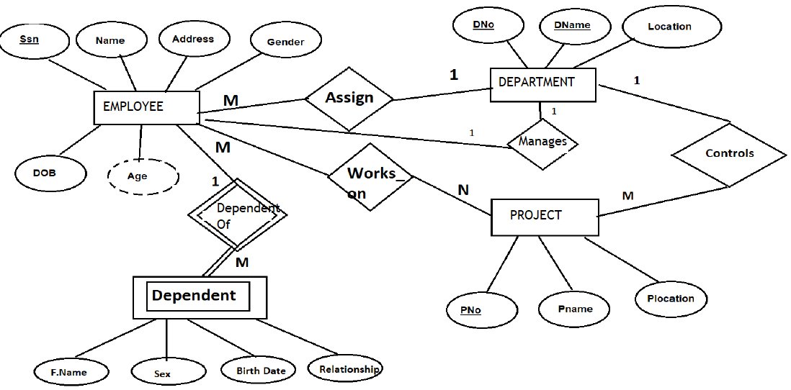 |  | 8 | II | L3
 | b |  | Describe the different types of integrity constraints that can be implemented in a database management system. |  | 4 | II | L2
OR
12 | a |  | What is the Cartesian product in a database management system, and how is it used to combine data from multiple tables? |  | 6 | II | L3
 | b |  | Create two tables in a database management system, and establish a relationship between them using SQL commands. Set appropriate constraints on the tables to ensure data consistency and accuracy.  Assume we have two tables: Employees and Departments. We want to establish a relationship between these tables such that each employee is associated with a department. |  | 6 | II | L3

Course Outcomes (CO):
CO I :
CO II :
Bloom’s Taxonomy Level:
L1: Remember, L2: Understand, L3:Apply L4:Analyze

